Test Case: tc001_SPX_Dev5_Crear_Requisicion_Spot_Tipo_Cobro_CC
Step 1 - Enter username and password and click to button Enter : Credentials Entered
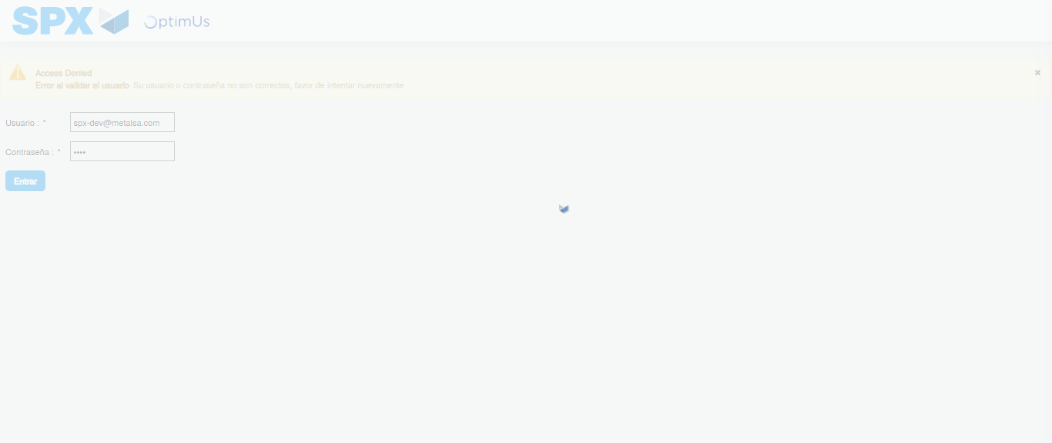Image file-name: QC_Testing-tc001_SPX_Dev5_Crear_Requisicion_Spot_Tipo_Cobro_CC-1783978492949

Step 2 - Select to UEN and Access to Spot Buy Requisitions : UEN Correctly selected and Correct access
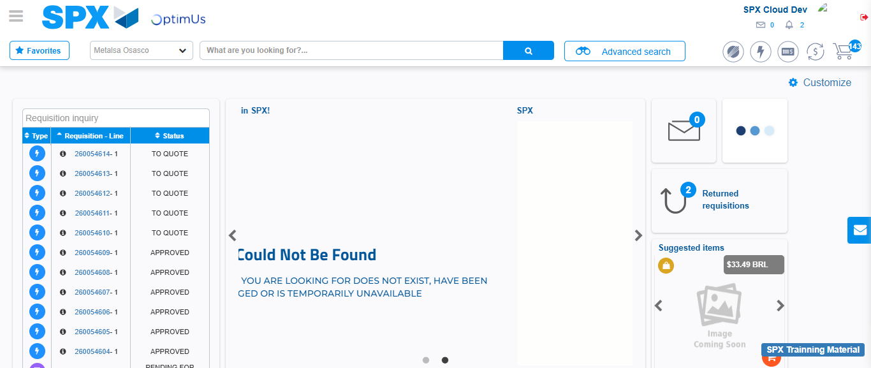Image file-name: QC_Testing-tc001_SPX_Dev5_Crear_Requisicion_Spot_Tipo_Cobro_CC-1783978519449

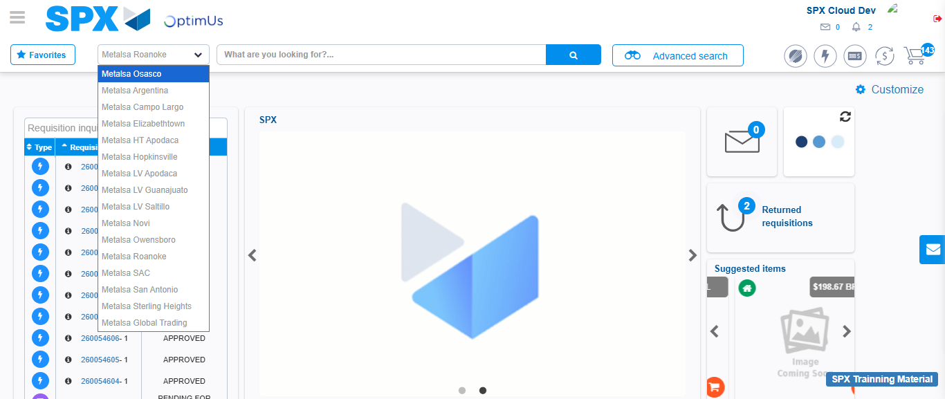Image file-name: QC_Testing-tc001_SPX_Dev5_Crear_Requisicion_Spot_Tipo_Cobro_CC-1783978522112

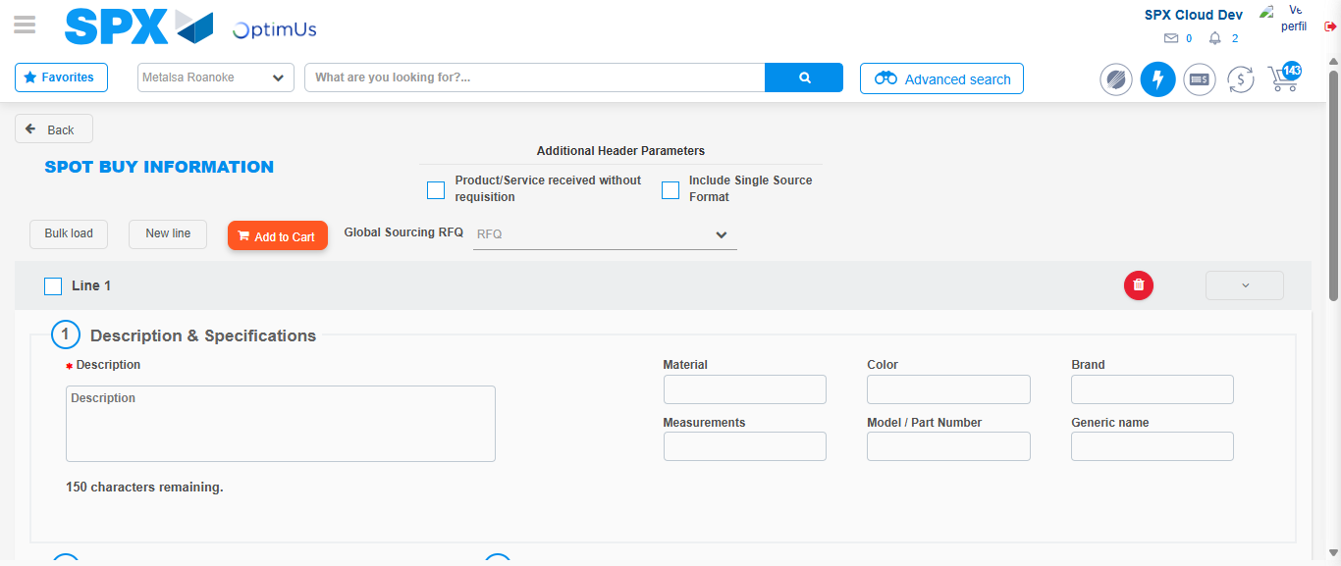Image file-name: QC_Testing-tc001_SPX_Dev5_Crear_Requisicion_Spot_Tipo_Cobro_CC-1783978543454

Step 3 - Data Capture Spot Buy Requisition : Data captured correctly
Image file-name: QC_Testing-tc001_SPX_Dev5_Crear_Requisicion_Spot_Tipo_Cobro_CC-1783978543714

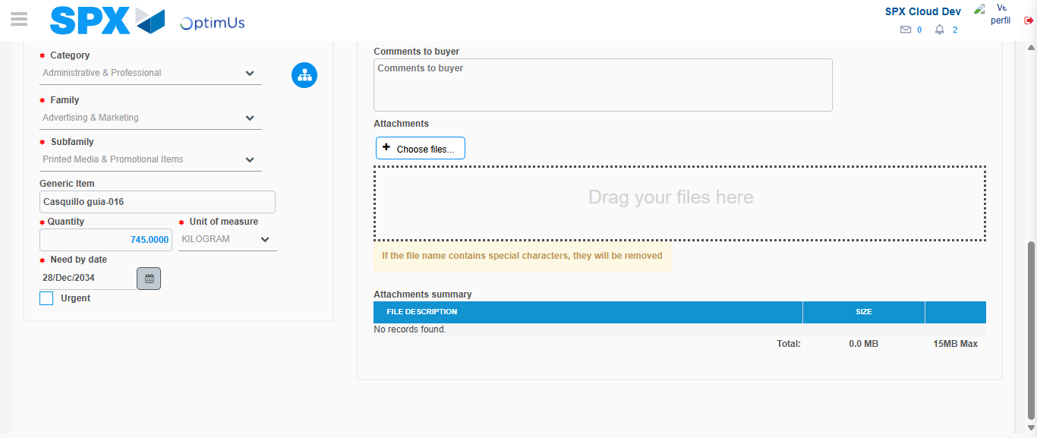Image file-name: QC_Testing-tc001_SPX_Dev5_Crear_Requisicion_Spot_Tipo_Cobro_CC-1783978555316

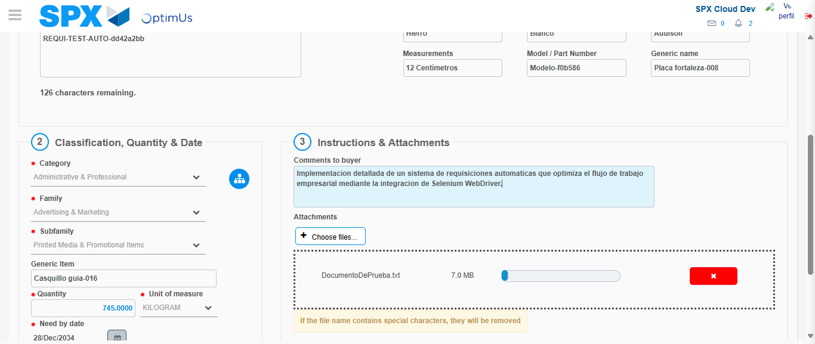Image file-name: QC_Testing-tc001_SPX_Dev5_Crear_Requisicion_Spot_Tipo_Cobro_CC-1783978556108

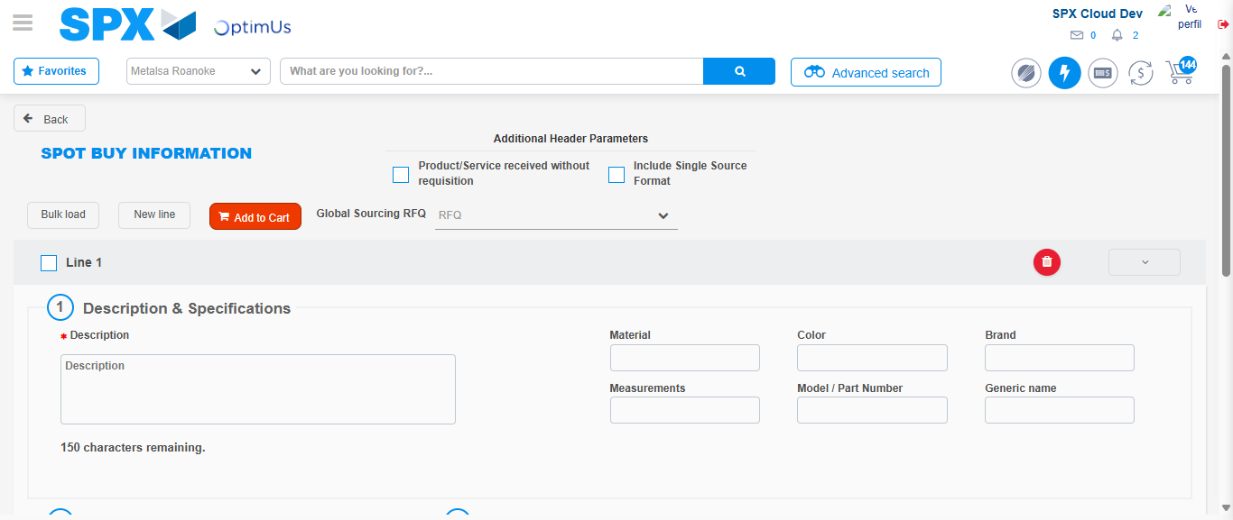Image file-name: QC_Testing-tc001_SPX_Dev5_Crear_Requisicion_Spot_Tipo_Cobro_CC-1783978566596

Step 7 - Return to Main Page SPX : Return to Main Page SPX
Image file-name: QC_Testing-tc001_SPX_Dev5_Crear_Requisicion_Spot_Tipo_Cobro_CC-1783978519449

Image file-name: QC_Testing-tc001_SPX_Dev5_Crear_Requisicion_Spot_Tipo_Cobro_CC-1783978522112

Image file-name: QC_Testing-tc001_SPX_Dev5_Crear_Requisicion_Spot_Tipo_Cobro_CC-1783978543454

Image file-name: QC_Testing-tc001_SPX_Dev5_Crear_Requisicion_Spot_Tipo_Cobro_CC-1783978568787

Image file-name: QC_Testing-tc001_SPX_Dev5_Crear_Requisicion_Spot_Tipo_Cobro_CC-1783978568953

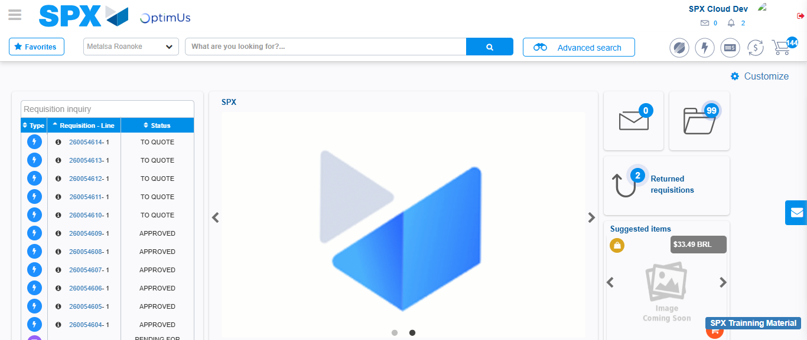Image file-name: QC_Testing-tc001_SPX_Dev5_Crear_Requisicion_Spot_Tipo_Cobro_CC-1783978589903

Step 8 - Log Out : Log Out SPX
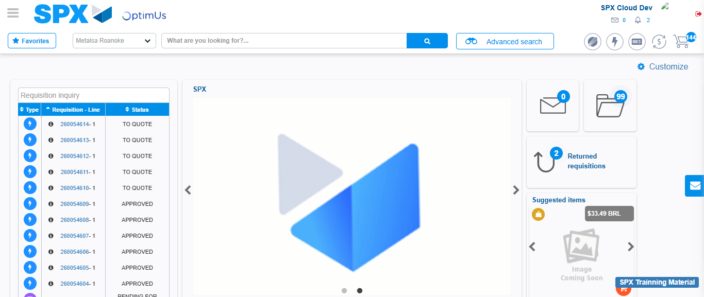Image file-name: QC_Testing-tc001_SPX_Dev5_Crear_Requisicion_Spot_Tipo_Cobro_CC-1783978590176

